

**Case IH Agriculture Equipment, Inc**.

**For More Information, contact:**

Dan Danford 262/636-7359

[dan.danford@caseih.com](mailto:dan.danford@caseih.com)

or

Ryann Greve 262/636-5921

[ryann.greve@caseih.com](mailto:ryann.greve@caseih.com)

**Press Materials**

**CASE IH AWARDS RAM TRUCK IN FIELD OF DEALS SWEEPSTAKES**

**RACINE, Wis.** (Oct. 2, 2012)

Case IH recently awarded grand prize winner Craig Gulstad of Glenfield, N.D., a new 2012 Ram truck and free fuel for one year in the Case IH Field of Deals Sweepstakes. Gulstad – a wheat, soybean and beef cattle farmer – registered for the contest at his local Case IH dealership, High Plains Equipment in Devils Lake, N.D.

“This is the first new vehicle I’ve ever owned,” says Gulstad. “It will be put to good use and certainly will be an asset to my farming operation.”

The Case IH Field of Deals Sweepstakes also awarded two runner-up prizes of $10,000 in credit to Keith Schroeder of Ottawa, Ohio, and Aaron Mickelsen of Moses Lake, Wash.

Kyle Russell, Senior Director of Marketing, Case IH North America, says many of their customers benefitted from the Field of Deals sweepstakes and sales event because so many took advantage of the special offers on the full line of Case IH Farmall®, Puma® and Maxxum® tractors, as well as balers and windrowers.

“Case IH has introduced a lot of new equipment and is gearing up for the 2013 season,” Russell says. “Many producers are visiting local Case IH dealers to see the new tractors and hay tools firsthand.”

To learn more about current deals, visit [www.caseih.com/deals](http://www.caseih.com/deals).

Case IH is a global leader in agricultural equipment, committed to collaborating with its customers to develop the most powerful, productive, reliable equipment – designed to meet today’s agricultural challenges. Challenges like feeding an expanding global population on less land, meeting ever-changing government regulations and managing input costs. With headquarters in the United States, Case IH has a network of dealers and distributors that operates in over 160 countries. Case IH provides agricultural equipment systems, flexible financial service offerings and parts and service support for professional farmers and commercial operators through a dedicated network of professional dealers and distributors. Productivity enhancing products include tractors; combines and harvesters; hay and forage equipment; tillage tools; planting and seeding systems; sprayers and applicators; site-specific farming tools and utility vehicles. Case IH is a brand of CNH (NYSE: CNH), a majority-owned subsidiary of Fiat Industrial S.p.A. (FI.MI).

###

For more information, visit [www.CaseIH.com](http://www.CaseIH.comp).

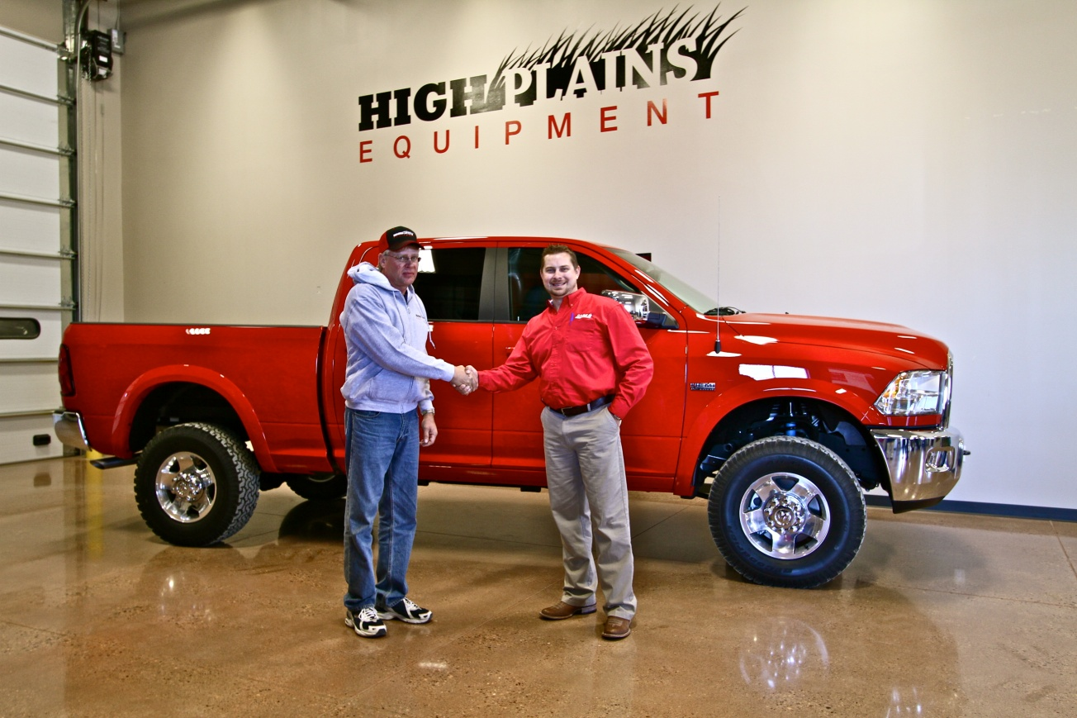

**Photo caption:**

Case IH Regional Sales Director Scott Raber recently presented Craig Gulstad of Glenfield, N.D., with a new 2012 Ram truck and free fuel for one year. Gulstad was the grand prize winner in the Case IH Field of Deals Sweepstakes.